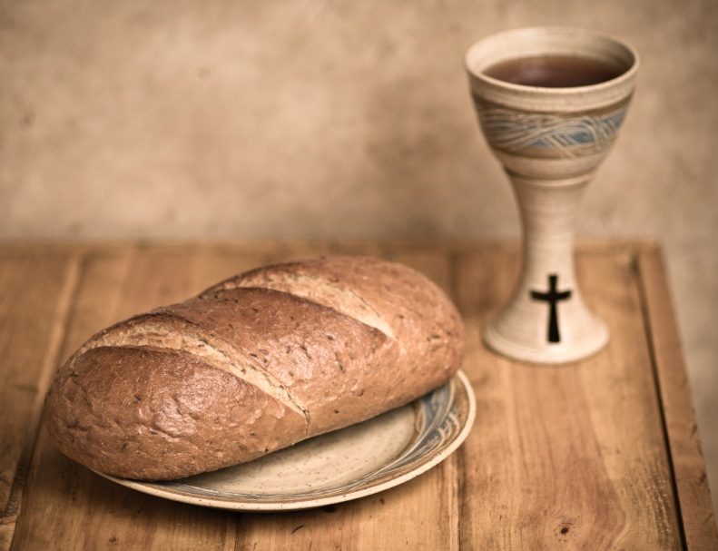
First United Church
of Bloomington, Indiana
www.firstuc.org

~~~~ World Communion Sunday ~~~~
10:30 A.M October 04, 2020

PRELUDE Hansol Kim

WELCOME AND ANNOUNCEMENTS

A TIME OF CENTERING

CALLED INTO COMMUNITY
One: On the first Sunday of October, we come together with other Christian
congregations from around the world to celebrate the unity to which we are called as followers of Jesus. Though our denominations, languages, and specific beliefs and practices may vary, the focus of this day reminds us of Jesus’ teachings and the radical unity that defined the early church.
All: As our human siblings around the world remember us this day in the spirit of
Communion, let us remember them as well.
One: If you are comfortable, please close your eyes, inhale a deep breath, then
exhale. Together, in our hearts and minds, let us bring to our consciousness the love we have for the people of our own church. Now let us visualize sharing that same love with:
all the people of Bloomington
all the people of Indiana
all the people of our country
all the people of our continent
all the people of all the continents.
All: We have never met, and will never meet, a person God does not love. Earth, with
all its messiness, is the place where God’s family lives. As we continue worship, may we keep this global consciousness and the spirit of unity in our hearts.

*HYMN For the Healing of the Nations No. 576

PRAYER OF BEGINNING
One: We, whose roots lie in Africa,
We, whose roots lie in Asia,
We, whose roots lie in South America,
We, whose roots lie in Australia and Oceania,
We, whose roots lie in Europe,
We, whose roots lie in North America,
We, whose roots are unknown,
We, whose roots are laden with pain and tragedy,
We, whose roots contain stories of triumph and hope,
We are God’s people, tasked with loving one another and enacting justice in our lands. Loving God, please hear our prayer.
All: Holy and gracious God, help us be receptive to your presence among your people, those who gather for worship, and all your people throughout the world,
as you see each of us out to invite us to a banquet of equality, in lands where justice rolls like water and mercy springs forth like new growth.
Help us to work together, to put the “unity” in your “community” for the betterment of our world. Amen.

READING FROM THE CHRISTIAN SCRIPTURES Matthew 21: 33-46 Pg.

PRAYER OF CONFESSION & WORDS OF ASSURANCE
One: Lord, our scriptures teach us that you are our creator and that we are each made in your image. Therefore each person we meet is a reflection of you, worthy of our love and respect, acceptance and compassion, mercy and justice. Yet, we do not always live that way.
All: In our thoughts earlier we may have seen flashes of stereotypes we believe about the people living in various parts of the world. Where those stereotypes contained prejudiced ideas, please forgive us, for they keep us from seeing our fellow people as you do. Where we feel hatred toward groups of people, please forgive us, for hatred keeps us from loving God and people the way you ask us to. Where there are other ideas, attitudes, or actions in our lives that keep us from the divine task of loving our neighbors as ourselves, please forgive us, for these are the things that separate us from you, and that cause strife in our world. Please hear our silent confessions.
[silence is held]

WORDS OF ASSURANCE:
One: Beloved friends, God’s love is the most powerful force in the universe, and God
invites us to share in it again and again. We can be confident in our forgiveness, and in our callings to respond to God’s outpouring of love with our own. Today is a new morning, a new beginning, a new opportunity to align our hearts with God’s. Amen.

HYMN We Walk In Love Deanna Witkowski
We walk in love, united in purpose
We join our hands and lift up one voice
We speak the truth with strength and compassion
Resounding with hope, with courage and joy.

CHILDREN’S TIME

HYMN What a Glad Day No. 4
PRAYERS OF THE PEOPLE

READING FROM THE CHRISTIAN IPTURES: Philippians 3:4-16

SERMON “The Only Way?” Rev. John Krueger

HYMN Come, We Who Love God’s Name No. 379

COMMUNION LITURGY

One: In Luke's Gospel we read that Jesus, at table with two of the disciples, took bread and blessed it and broke it, and gave it to them, and their eyes were opened, and they recognized the risen Christ in the breaking of the bread.
In the Acts of the Apostles we read that as the church was gathered, often in the homes of the believers, Christians devoted themselves to the apostles' teaching and community, to the breaking of bread, and to prayers.
All: Jesus Christ, the Bread of Life, we gather at your table to know you in the breaking of the bread.

PRAYER OF OUR SAVIOR (FROM THE NEW ZEALAND PRAYER BOOK)
Eternal Spirit, Earth-maker, Pain-bearer, Life-giver, Source of all that is and that shall be, Father and Mother of us all, Loving God, in whom is heaven:

The hallowing of your name echo through the universe!
The way of your justice be followed by the peoples of the world!
Your heavenly will be done by all created beings!
Your commonwealth of peace and freedom sustain our hope and come on earth.

With the bread we need for today, feed us.
In the hurts we absorb from one another, forgive us.
In times of temptation and testing, strengthen us.
From trials too great to endure, spare us. From the grip of all that is evil, free us.

For you reign in the glory of the power that is love,
now and forever. Amen.

WORDS OF INSTITUTION

SHARING OF THE ELEMENTS

PRAYER OF THANKSGIVING

COMMUNION HYMN This is My Song No. 591

SENDING FORTH

